**Theme: Make Entrepreneurship Your Breakthrough**

**By: Lintle Motlomelo BAPC Y3S2**

# **Introduction**

The PR Y2 and BAPC Y4 campaign was a successful event that was executed and carried out in a professional and elegant manner. This event was surely a success and a motivation to all the students who participated and the guests who were invited. Making entrepreneurship a breakthrough is a theme that should a leading focus and ever present in the mind of all Basotho youth and this event surely made that statement one to always be remembered. This portfolio is a reflection and overall assessment of the planning and execution of the BAPC Y4 and PR Y2 public relations campaign, as well as recommendations for the next campaign.

# **Planning**

In class we learned that a successful event depends on inclusive, effective and detailed planning and coordination between stakeholders. Seitel (2017) agrees by stating that any public relations campaign is a combination of all the facets of public relations planning in terms of objectives, strategies, research, budgeting, tactics, and evaluation of everything into one organised structure. The responsibility of planning a successful event depends on different role players. The success in planning this campaign relied heavily on the corporation between the BAPC Y4 and PR Y2 students. This collaboration paid off because of how well the students played their roles during the planning and execution of the event. With help and recommendation of ideas from the BAPC Y3 students, this event became the success it was intended to become.

Guest List

The guests invited were very relevant to the theme of the event. The people invited and the guest speakers were only those who could help in successfully executing the main idea behind the event and delivering the messages accurately.

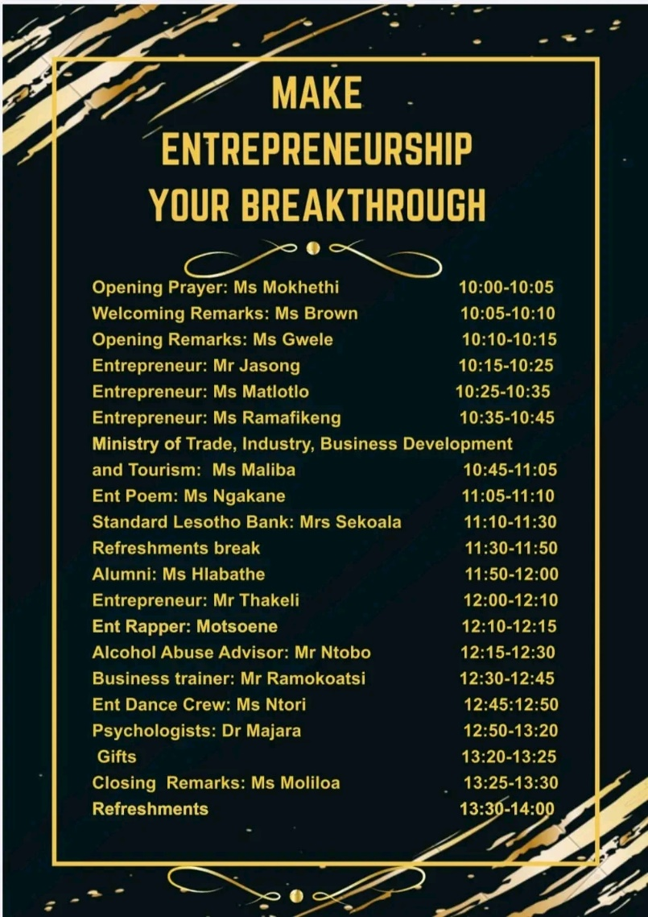

**The guest list for the event. Some of the stakeholder on the list were recommended by the BAPC Y3 students.**

Dress code

The dress code was simple, yet elegant and it gave of a corporate feel. Black is a colour that is both classy and corporate and the touch of gold gave more glass to the whole dress code. Overall, the dress code highly was highly suitable for the event.

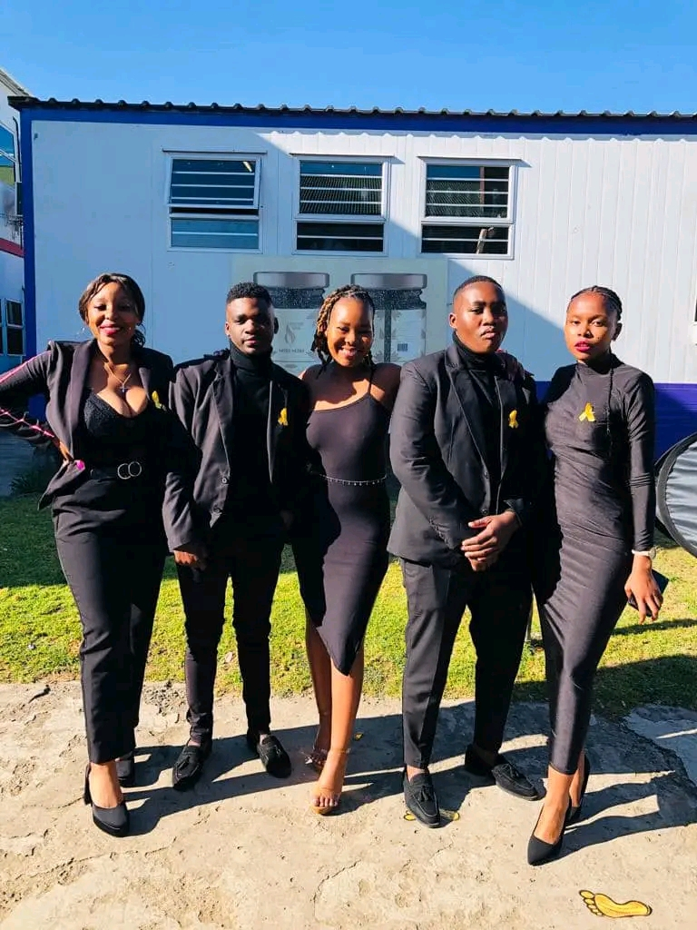**PR Y2 students before the event**

Venue

Choosing Hall 9 as the venue was a good idea because it accommodated for all the invited guests and it was in a place that received the least noise from students outside and everyone else carrying out their duties within the campus.

# **Event execution**

Make entrepreneurship your breakthrough was a fitting theme for this event. The main idea behind this event was well thought out and executed. The event execution was a job well done considering this was planned by students and for most of them this was their first time. However, every event comes with its own setbacks.

* The main problem during the event is that some of the invited guest speakers showed up with other people who had not been catered for. For example, the people who accompanied the guests did not receive any gifts because the gifts were only enough for people who got invitations
* Again, most of the guest speakers failed to deliver their speeches within the time that was allocate to them. While others failed to show up on time and others failed to attend.
* Another major setback was that the students were mainly in charge of entertaining the guests during the event. Some of them did good in making sure that the guests were entertainment, however others did very poorly and bored the people present.

In overall, the event execution was a success. The MCs for the event were well articulated with their work and they did their part beautifully. The Coordinators made sure that the event flows smoothly and controlled the minor inconveniences that were done by some of the students present with professionalism. Again, the catering was good and the food was well served for everyone present. The PR material for the event was well placed and it gave away the theme and the goal of the campaign effortlessly.

# **Recommendations**

For upcoming event I would like to recommend that students should all be made clear of their roles during the campaign and how they are expected to conduct themselves. Moreover, when it comes to the PR material, it was not enough to make a clear statement of what was happening. My recommendation is that the next time there should be more poster, backdrops and any other PR material needed to communicate the message behind the event. Also, that the decoration should be done more elegantly and neatly.

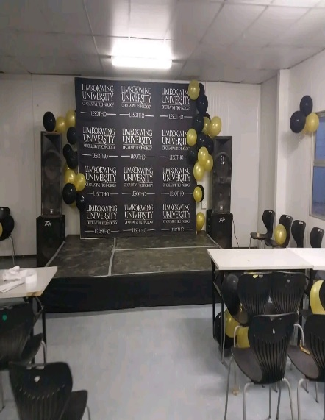**This shows what the stage looked like during the event**

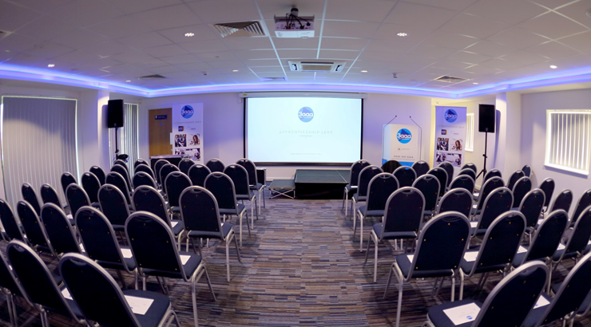 **The recommended look for the stage**

Another recommendation is that the quests should also be made aware of the dress code and they should be advised to at least try to match it if they can. Plus a professional photographer should be hired to cover the event pictures. The school has many photographers who are aspiring professionals who would be honoured to get invited to cover such events.

# **Conclusion**

In conclusion, this PR campaign was a great inspiration to everyone attending. The guest speakers highly motivated everyone present and inviting some of the alumnus from the school as speakers made it more impactful. In the future as a BAPC student I hope we can achieve similar greatness that was and learn events planning from this experience. Lastly for the next campaign I believe my class will do a lot better and deliver even more great results.

# **Stories in Pictures**

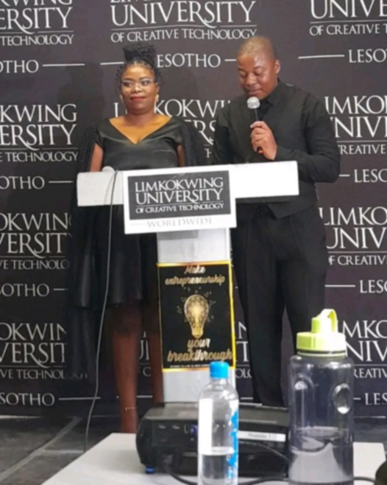 **Event MCs 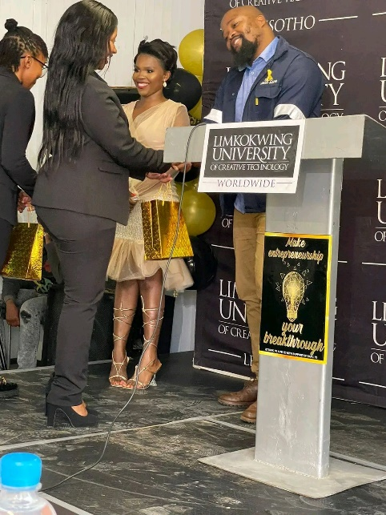 Gift Ceremony**

** Event Posters 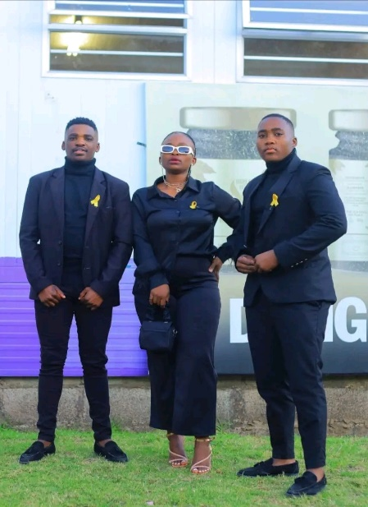 PR Students**

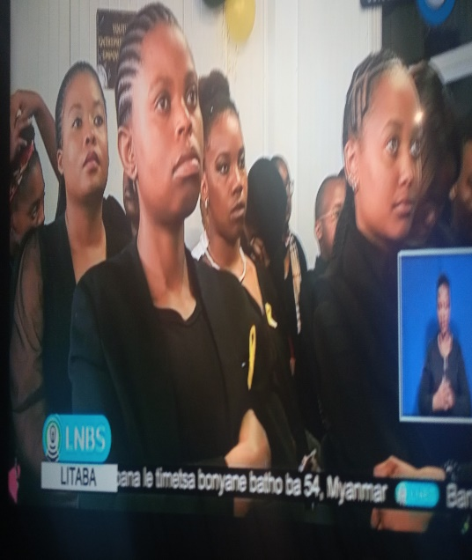 **PR Campaign on LNBS News**

# **References**

Seitel, F.P. (2017). The Practice of Public Relations. 13th ed. Harlow: Pearson Education limited.